# Lab 4:

Name: misbah zehra

Class:IT 3A

BIT-23F-025

Write a Python function to check if a number is even or odd.

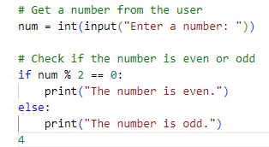

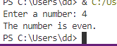

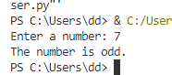

### Simple ATM Machine Create a simple ATM program where the user has to enter a PIN to proceed.

* The correct PIN should be 1234.
* If the user enters the correct PIN, display a menu that allows the user to:
  + **Check Balance** (display a fixed balance, e.g., 1000).
  + **Withdraw Money** (ask the user how much they want to withdraw and deduct that amount from the balance).
* If the user enters an incorrect PIN, print "Incorrect PIN" and terminate the program

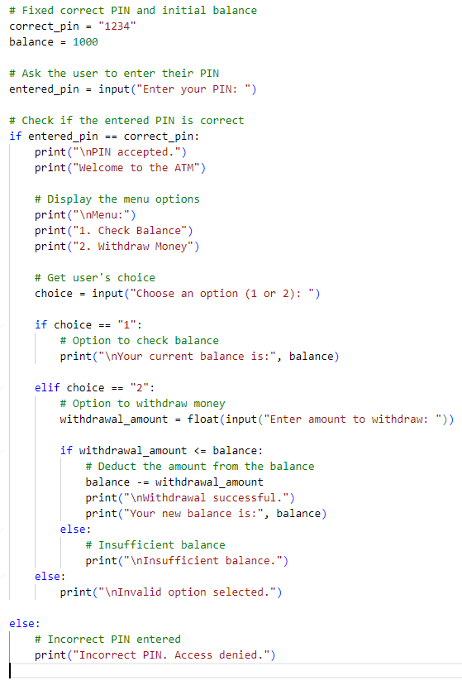

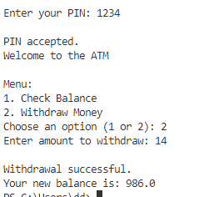

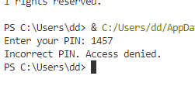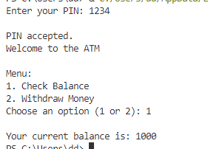

Write a program that asks the user to enter a **username** and **password**.

* The correct username should be "admin" and the correct password should be the **numeric value** 12345.
* If both the username and password are correct, the program should display "Login Successful!".
* If the username is incorrect, display "Incorrect username".
* If the password is incorrect, display "Incorrect password".

